

**Mrs. Alvarado’s**

**Pre-Primary Supply List**

Please label all supplies with your child’s first and last name

* 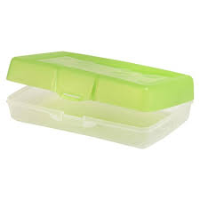Backpack – Must be large enough to fit a folder and a notebook. No mini backpacks please.
* 1 plastic pencil box (8 ½ x 5 ½)  *\* see picture*
* 1 pair of scissors (5” blunt tip)
* 2 boxes of 24 count Crayola crayons
* 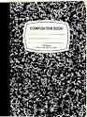1 clipboard
* 2 marble composition notebooks *\*see picture*
* 2 PLASTIC folders – 1 red, 1 blue
* 1 ream of white printer paper
* 12 glue sticks (no glue pens please)
* 1 box of tissues
* 1 roll of paper towels
* 1 container of Clorox or Lysol disinfecting wipes
* Headphones (no earbuds please)
* 1 complete set of seasonally appropriate clothes in a Ziploc bag labeled with your child’s name. Please be sure to include pants, shirt, underwear and socks.

* Students will have individual supply boxes, rather than communal supplies. Because of this, supplies such as crayons, pencils and glue will likely need to be replenished at some point during the school year.